**bin:**

Puts continuous numerical values into discrete sets, or bins, by adjusting the value of <field> so that all of the items in a particular set have the same value.

index=chppdata|bin span=12h _time|table Tag _time

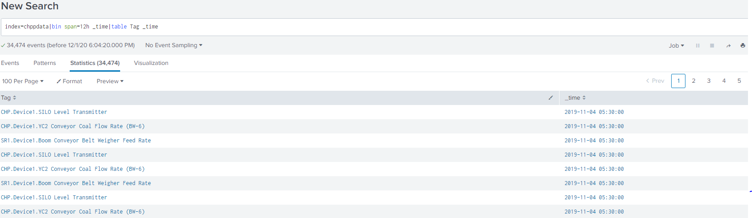

**chart:**

The chart command is a transforming command that returns your results in a table format. The results can then be used to display the data as a chart, such as a column, line, area, or pie chart.

|makeresults|eval A="1,2,1,2,1,3,3"|makemv delim="," A|mvexpand A|chart count by A

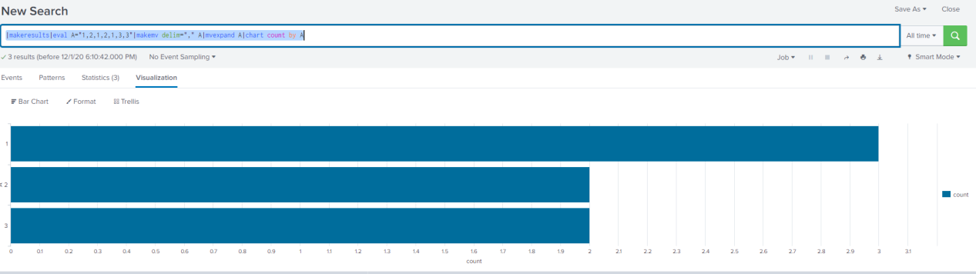

**collect:**

Adds the results of a search to a summary index that you specify.

**Syntax:**

collect index=<string>

**delta:**

Computes the difference between nearby results using the value of a specific numeric field.

index=chppdata|top 10 Value|delta count p=2

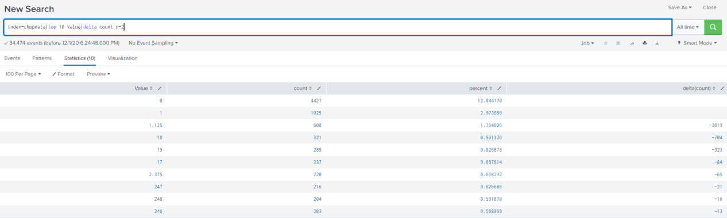

**foreach:**

Use this command to run a streaming subsearch that uses a template to iterate over each field in a wildcarded field list.

|makeresults | eval total=0 | eval test_1=1 | eval test_2=2 | eval test_3=3 | foreach test* [eval total=total + '<<FIELD>>']

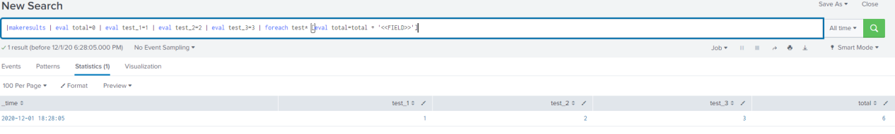

**reverse :**

Reverses the order of the results.

|makeresults|eval A="1,2,1,2,1,3,3"|makemv delim="," A|mvexpand A|reverse

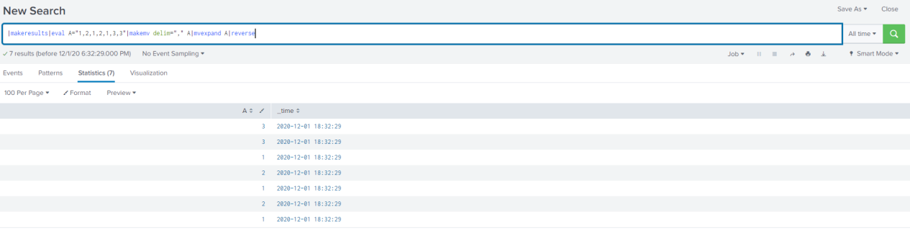

**transpose:**

Returns the specified number of rows (search results) as columns

|makeresults|eval A="1,2,1,2,1,3,3"|makemv delim="," A|mvexpand A|table A|transpose

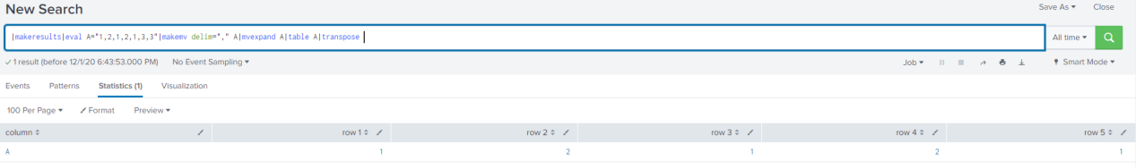

**Join:**

To combine the results of a subsearch with the results of a main search.

|makeresults|eval A="1,2,1,2,1,3,3"|makemv delim="," A|mvexpand A|table A|join A[|makeresults|eval A="2,3,"|makemv delim="," A|mvexpand A|eval B="1,2,2"|makemv delim="," B|mvexpand B|table A B]

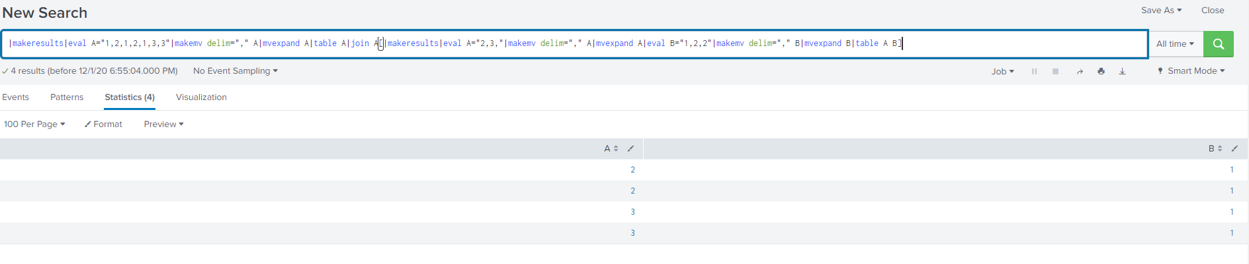

**analyzefields:**

Analyze the numerical fields to predicate the value of “is_activated”.

| inputlookup kv_summarydata | analyzefields classfield=count

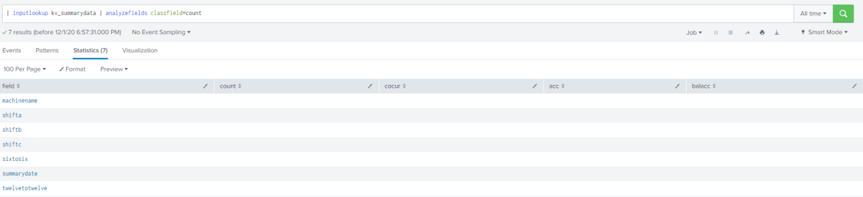

**dbinspect:**

Returns information about the bucket in the specified index.

|dbinspect index=chppdata

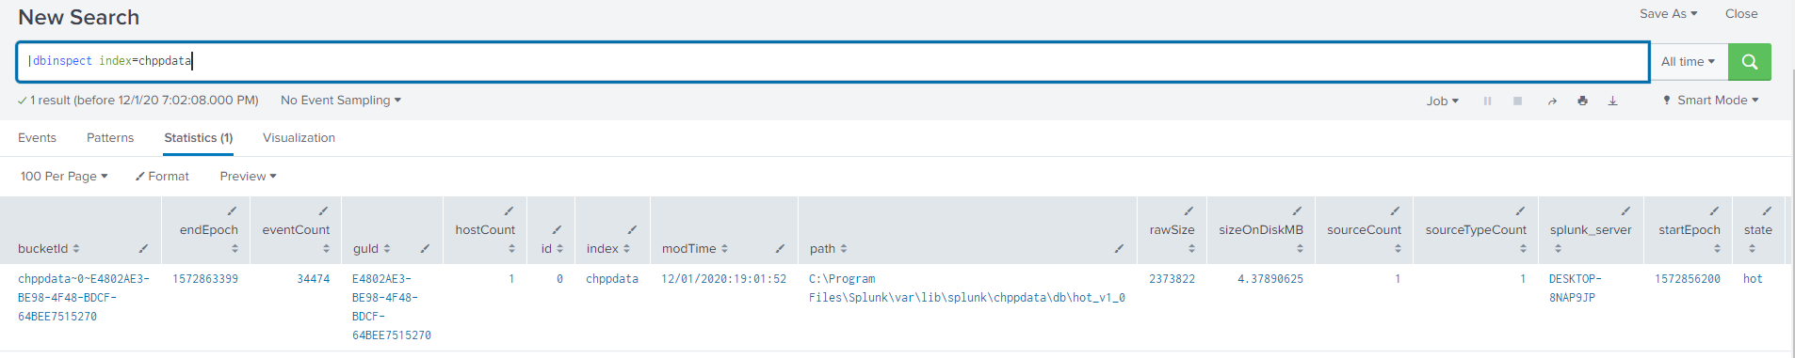

**replace:**

Replaces field values with the values that you specify.

|makeresults|eval A="1,2,1,2,1,3,3"|makemv delim="," A|mvexpand A|table A|replace 3 with 4

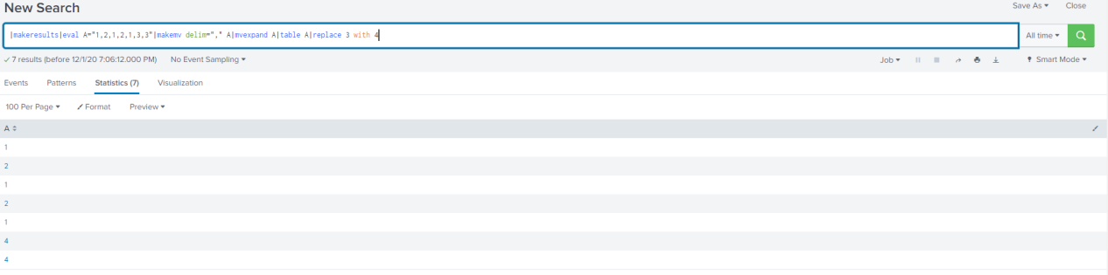

**savedsearch:**

Runs a saved search, or report, and returns the search results of a saved search.

**Syntax:**

| savedsearch <savedsearch_name>

**return:**

Returns values from a subsearch.

index=chppdata|return source

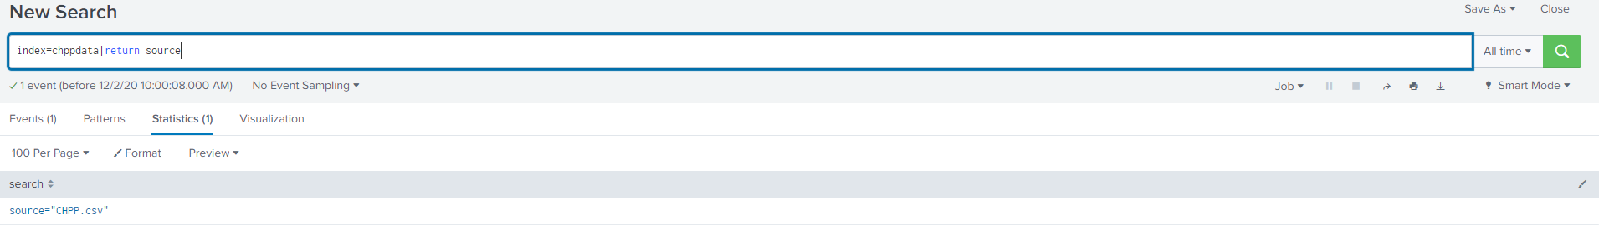

**search:**

Use the search command to retrieve events from indexes or filter the results of a previous search command in the pipeline.

index=chppdata| search Value=12.1993|table Tag Value

